Tensile Testing
[Name]
Saginaw Valley State University
Department of Mechanical Engineering
Principles of Engineering Materials Laboratory (ME250L)

Abstract
Most of the aluminium alloys that are extruded have some mechanical properties that are anisotropic. In this report, the strain-stress behavior of aluminium 7075 alloys was experimented using a tensile machine. The experiment was conducted in three different directions which were in respect to the extrusion behaviors. The experiment was conducted to analyze the mechanical properties of heated aluminium alloy and the discussion about their comparison were made from the values extruded from the tensile machine. In the experiment, cross arm displacement and extensometer displacement were the methods that were used to collect data from the aluminium alloy accurately.
Keywords: tensile stress, true strain, true stress, aluminium 7075

Tensile Testing
Introduction
Aluminium alloys have many engineering applications due to their mechanical and structural properties. The aluminium alloys are light and have the crashworthy capabilities which are preferred in most of the automotive industries. The alloys have high strength and are light which is then used in most of the aerospace design and manufacturing. Therefore, the increased number of manufacturing designs of these aluminium alloys have made it necessary to have better testing material models where they are perfectly studied with perfection and coefficients involved in the material model are carefully identified.
There are some investigators who have conducted aluminium alloy test. At room temperature, Oosterkamp et al. (1999) conducted a compression test at aluminium 7075 that resulted in a small increase in the stress flow concerning the strain rate. Reyes et al. (2006) experimented using other alloys of aluminium 7075 and go similar sensitivity observation. Børvik et al. (2005) conducted the flow stress and structure strain where the results showed a strong and positive sensitivity on the strain rate. El-Magd and Abouridouane (2006) did the tension test, and the result showed that the flow stress increases slightly with the strain rate. However, the increasing rates at deformation decreased in tension and increased in tension. When Clausen et al. (2004) measured the fracture strains at different strain rates in all tension tests, the results were such that the fracture strains is independent in the dynamic strain regime where it increases considerably at higher rates.
Therefore, to calculate these stress-strain analyses, different formulas were used which are:
Ϭ=S (1+ δ)
ℰ= ln (1+ δ)

Where
- Ϭ=true stress
- δ= engineering strain
- ℰ= true strain
- S=engineering stress
Objectives
- To determine the yield strength, ultimate tensile strength, and elongation for aluminum samples in two different heat treat conditions
- To compare the use of crosshead and extensometer displacement measurements
- To examine how cold working increases the strength of an aluminum alloy

Procedure
One 7075 Aluminium specimen that was cold worked and two 7075 aluminium that were heat treated by annealing them in the air for three hours at 415 °C. Literature data of the mechanical properties; tensile strength, yield strength and ductility of the specimens were derived from the textbox's appendix. The data was used to generate functions of engineering stress against engineering strain.
Drawbacks
The tensile test machine is very expensive, with its price being not less than $10000. Furthermore, the machine is susceptible to failure in case of overload.
Before the tensile test was done, the load cell rated maximum capacity was checked so as not to overload the system. The highest tensile strength that the machine could tolerate was calculated by dividing the cross-sectional area of the gage length of the test specimen.
A spreadsheet containing time, load, crossarm extension and extensometer displacement was created based on the tensile test data generated by the loading cell machines software. This data was used to generate experimental graphs of engineering stress and strain. Comparisons of the experimental data and literature data were made. Also, differences between the extensometer displacement and crossarm displacement were studied.
The following formulas were used to generate additional data;
P = load
A_{o} = initial cross-sectional area of the specimen
s = engineering stress = P / A_{o}
L_{o} = gauge length measured on the specimen (4 inches)
∆ L = crossarm extension
e₁ = engineering strain measured from the crossarm displacement = ∆ L / L_{o}
L₂₀ = extensometer knife edge separation before tensile test (2 inches)
L₂ = extensometer knife edge separation at any time during the tensile test
e₂ = engineering strain measured from the extensometer = (L₂ - L₂₀) / L₂₀
True stress and strain were also calculated.
A = instantaneous cross-sectional area of the specimen
σ = true stress = P/A = s (e2 + 1)
ε ₁ = true strain measured by crossarm displacement = ln [(∆ L + L₀)/L₀] = ln (e₁ + 1)
ε ₂ = true strain measured by extensometer = ln (L₂/L₂₀) = ln (e₂ + 1)
The test was done in four phases. The first specimen, cold worked 7075 aluminium, was loaded to failure and the results labeled as sample1. The second specimen annealed aluminium was loaded to failure.in the third test, annealed 7075 aluminium specimen was work harden by loading it above its yield point. This was referred to as sample 3. The specimen was then loaded again but to failure. This was sample4. The results from the four tests were used to generate graphs and values of Young's modulus yield strength, ultimate strength, stress, and strain were obtained.

Results and Discussions
Results from the cold worked 7075 aluminium which was loaded to failure are in the table below.
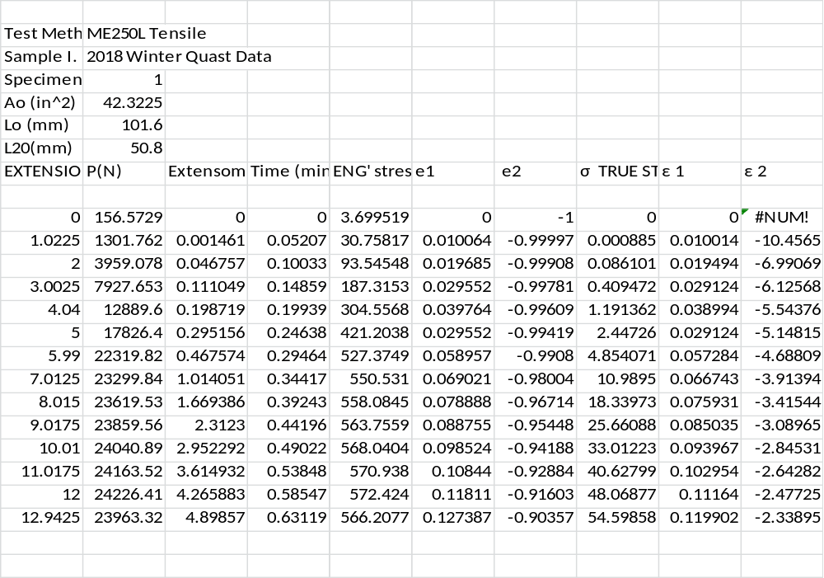
Table 1 sample 1 results
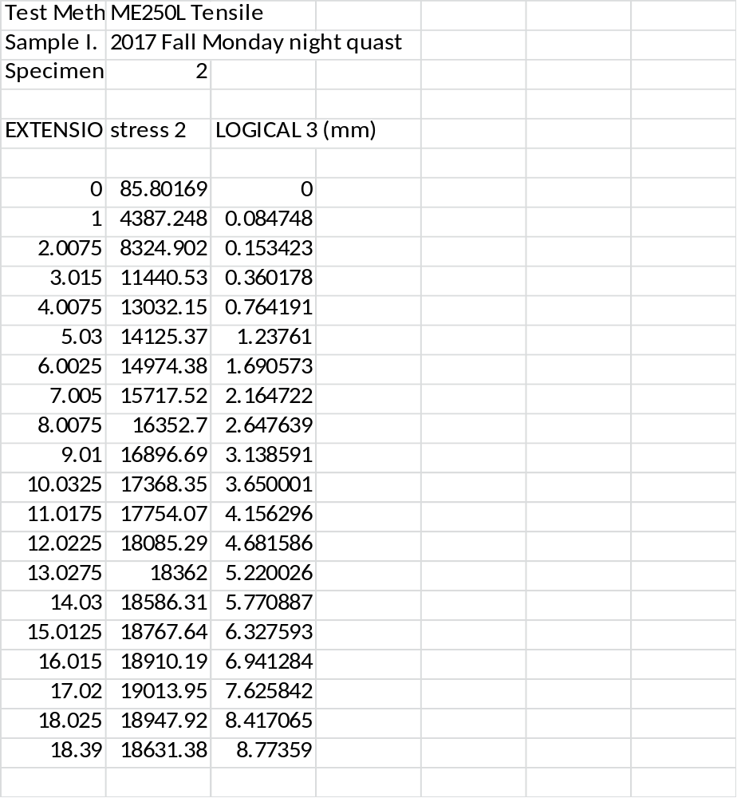
Table 2 sample 2 results
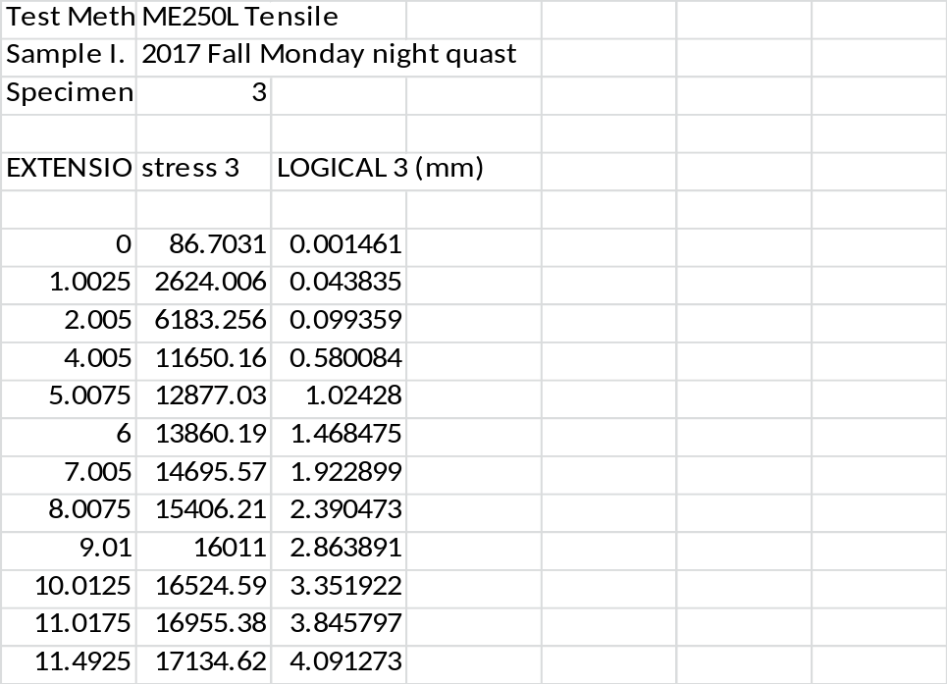
Table 3 sample 3 results
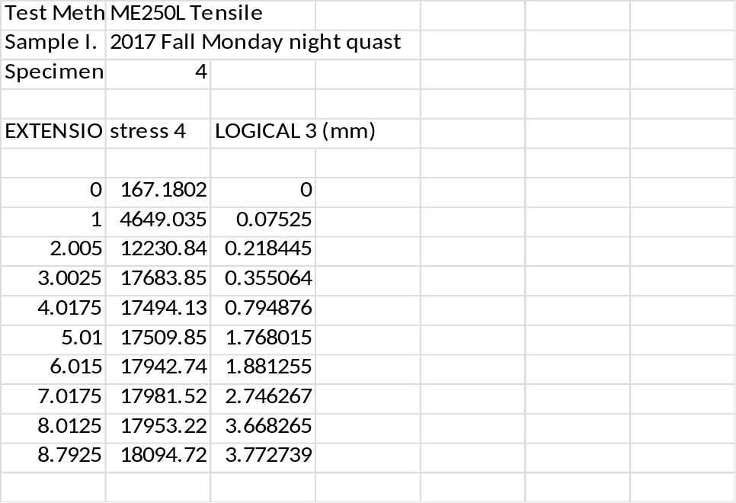
Table 4 sample 4 results

Figure 1 strain verse stress for sample 1 and sample2

The above is a plot of two curves: σ as a function ε 2 for sample1 and sample2. Cold worked aluminium has lower yield strength compared to annealed samples. However, annealed aluminium has superior strain hardening qualities. The fact that annealing involves heating the material under considerably high temperatures, a uniform lattice is formed as it cools thus minimizing the internal stress and cracks. Therefore, it has higher yield strength and higher strain-to-fracture ratio due to minimized internal stresses. It also can withstand higher ultimate load.

Figure 2 true stress verses true strain
Sample 4 offers the highest yield strength in comparison to the other specimen. This is because majorly annealed aluminum 7075 specimen was work hardened (sample 3) before the final experiment. This increased its yield strength at the expense of its strain hardening strength. Sample 3 offers higher yield strength as compared to sample 2 as well as strain hardening.
Meanwhile, sample3 exhibited higher ultimate strength and strain-to-failure in comparison to the other samples. This is due to the fact that it does not undergo any prior loading, therefore, there is minimal internal stress within the sample.

Figure 3 stress and trues stress verse strain graph
The true stress being a function of engineering stress, the two graphs do not cross at zero. The two stresses are proportional to each other.
.
Figure 4 strain verse engineering stress of sample 1
Young’s modulus (crossarm displacement);
$$E=\frac{stress}{strain}=slope=\frac{2376-399.4}{0.01949-0.01001}=208GPa$$
Young” modulus (extensometer displacement);
$$E=\frac{stress}{strain}=slope=\frac{2376-399.4}{-3.2347+3.9056}=2.9GPa$$
Crossarm displacement, e1 gives a more accurate value than the extensometer. Extensometer takes a recording of the average displacement. This explains why its values are less compared to the cross arm displacement method. In addition, calibration of the extensometer is rather difficult.
The literature values differ from the experimental data values. This is because experimental data is inclusive of the defects within the specimen while the literature data assumes the specimen has zero defects. These defects mainly occur during the manufacturing process.
CONCLUSION
Finite element software was used to conduct a test on four pieces of aluminium 7075 and determine their stress-strain relationships. Graphs from the data generated by the machine were used to plot graphs which aided in analyzing the mechanical properties of the specimens. Careful recording and reading of measurement and well calibrated gauges can reduce errors in the experiment.
EXPERIMENTAL ERRORS
Errors in the results from the data obtained could be due to faulty loading machine; machine flexes, measurement recording errors and calibration errors.

References
Børvik et al., 2005 T. Børvik, A.H. Clausen, M. Eriksson, T. Berstad, O.S. Hopperstad, M. LangsethExperimental and numerical study on the perforation of AA6005-T6 panels International Journal of Impact Engineering, 32 (2005), pp. 35-64
Clausen et al., 2004 A.H. Clausen, T. Børvik, O.S. Hopperstad, A. BenallalFlow and fracture characteristics of aluminium alloy AA5083-H116 as function of strain rate, temperature and triaxiality Mechanical Science and Engineering A, 364 (2004), pp. 260-272
El-Magd and Abouridouane, 2006 E. El-Magd, M. AbouridouaneCharacterization, modelling and simulation of deformation and fracture behaviour of the light-weight wrought alloys under high strain rate loading International Journal of Impact Engineering, 32 (2006), pp. 741-758
Oosterkamp et al., 1999 L.D. Oosterkamp, A. Ivankovic, G. VenizelosHigh strain rate properties of selected aluminium alloys Mechanical Science and Engineering A, 278 (1999), pp. 225-235
Reyes et al., 2006 Aa. Reyes, O.S. Hopperstad, O.-G. Lademo, M. LangsethModeling of textured aluminum alloys used in a bumper system: material tests and characterization Computational Materials Science, 37 (2006), pp. 246-268

